American Airlines new booking options for convenient and secure reservation management ☎️ +1 (866) 227-2650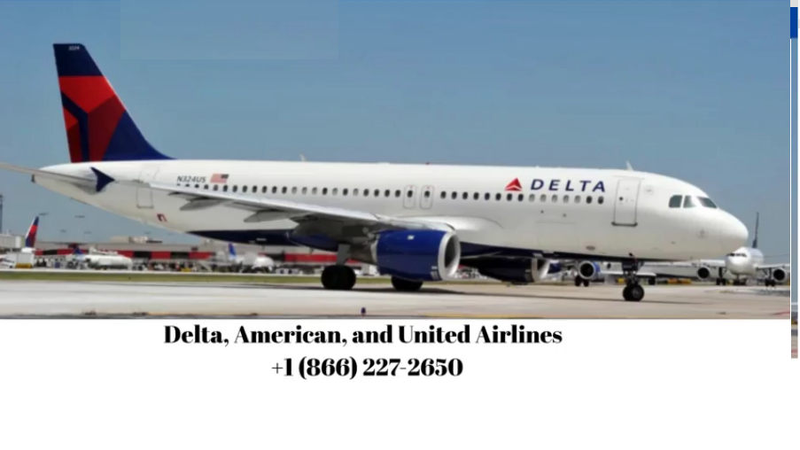

📞 Call Now: ☎️ +1 (866) 227-2650

Reliable, 24/7 assistance for Delta, American, and United Airlines travelers

Planning to buy a ticket, change your flight, or cancel your reservation? Our dedicated travel support team is here day and night to process your requests quickly and without stress.

📌 Why Choose Our Service? ☎️ +1 (866) 227-2650

✅ New Reservations – Instantly secure flights with Delta, American, or United

✅ Flight Modifications – Effortlessly update your schedule, route, or timing

✅ Cancellations – Phone-based cancellations with zero paperwork or long waits

🛫 What We Offer:

✔️ Professional booking help for Delta, United, and American Airlines

✔️ Quick and easy itinerary changes

✔️ Secure and prompt ticket cancellations

✔️ Friendly, real agents—never just a chatbot

📞 Don’t wait—connect directly with a live representative now: ☎️ +1 (866) 227-2650